**ASSIGNMENT:-2**

**EECE:-212**

**NAME: Shaharehar Rahaman Anik**

**Level: 2**

**ID No: 201916058**

**Here are some mathematical problem are solved by MATLAB 2020a.according to the questions. The answers are given bellow:**

**1. Write a MATLAB programs to find a real root of the following equation f(x) =x^3+10x^2-2x-10 by the Method of False Position. Use an accuracy level correct to 10 decimal place. Also find the number of iteration to achieve this accuracy**.

**Solution:**

Here is a function **f(x) =x^3+10x^2-2x-10,** have to be solved by method of False position and used an accuracy level correct to 10 decimal place. Also find the number of iteration to achieve this accuracy.

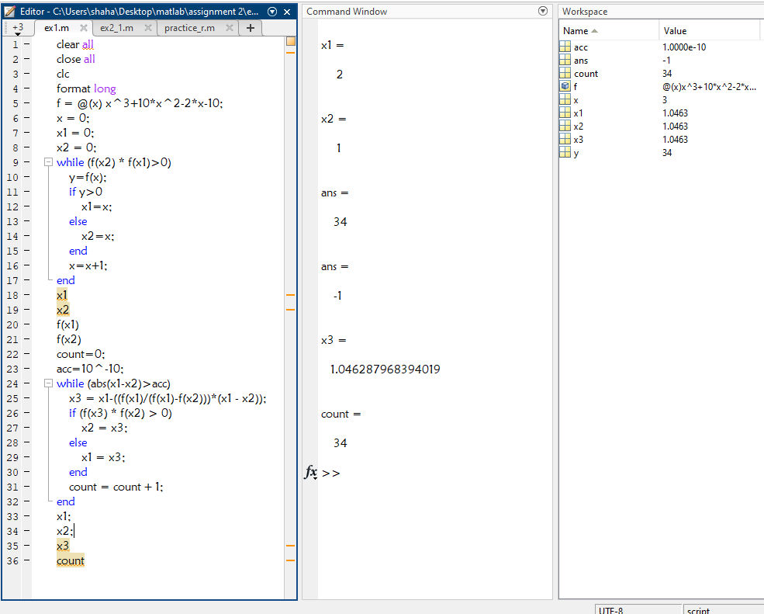

Here the solution is: **1.046287968394019**

Number of iterations: **34**

**2. Plot the values of x calculated in each iteration from the False Position Method's equation. (For this problem, you should store the calculated value of x in an array, then use that array to plot the curve)**

**Solution:**

Here have to Plot the values of x calculated in each iteration from the False Position Method's equation.

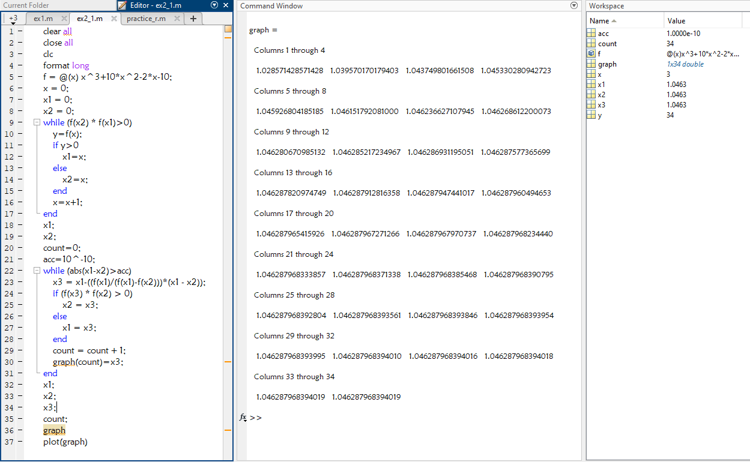

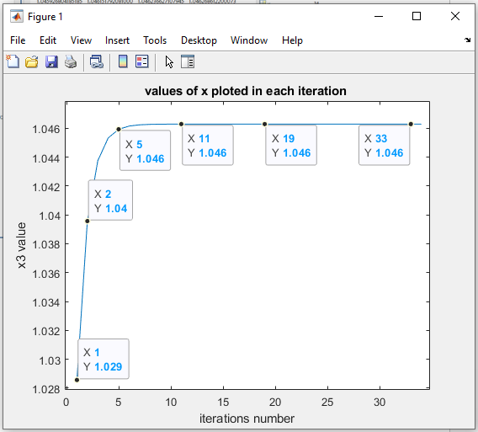

**Figure 1: the values of x vs Number of iterations**

**3. Find a real root of the above function using False Position Method by hand Calculation. Show the first three iteration.**

**Solution:**

Here we have to find out the real roots of the function using false position method by hand calculations. The first three iterations are shown:

**The function is:**

**x^3+10*x^2-2*x-10**

From the previous program we have got that,

**The upper value is, x1 = 2,**

For which the function gets the positive value.

Which is **f(x1) = 34**

**The lower value is, x2 = 1,**

Which is f**(x2) = -1**

For which the function gets the negative value.

**The false position method programing is:**

while (abs(x1-x2)>acc)

x3 = x1-((f(x1)/(f(x1)-f(x2)))*(x1 - x2))

if (f(x3) * f(x2) > 0)

x2 = x3;

else

x1 = x3;

end

count = count + 1;

end

According to **false position method:**

**1st iteration:**

$$x3=x1-\frac{f(x1)}{f\left(x1\right)-f(x2)}*(x1-x2)$$

**Or, $$x3=2-\frac{34}{34-\left(-1\right)}*\left(2-1\right) \\ = 1.028571428571428$$**

Now in the loop:

**f(x3)= -0.3893644315 , f(x2)= -1**

**f(x3)*f(x2)>0**

so according to loop

**x2=x3;**

that means **x2 = $1.028571428571428$**

and so now **f(x2)= -0.3893644315**

now in the

**2nd iteration :**

$$x3=x1-\frac{f(x1)}{f\left(x1\right)-f(x2)}*(x1-x2)$$

**Or, $x3=2-\frac{34}{34-\left(-0.3893644315\right)}*(2-1.028571428571428$)**

$$=1.039570170179403$$

Now in the loop:

f**(x3)= -0.1486090885, f(x2)= -0.3893644315**

**f(x3)*f(x2)>0**

so according to loop

**x2=x3;**

that means  **x2 = $1.039570170179403$**

and so now **f(x2)= -0.1486090885**

now in the 3rd iteration :

$$x3=x1-\frac{f(x1)}{f\left(x1\right)-f(x2)}*(x1-x2)$$

**Or, $x3=2-\frac{34}{34-\left(-0.1486090885\right)}*(2-1.039570170179403$)**

$$= 1.043749801661508$$

So, finally the 3 iterations are:

$1.028571428571428$

$1.039570170179403$

$1.043749801661508$